It's another name is **"The Statue of Unity"**. But local people mention it as **"Sardar Vallabhbhai Patel statue"**. It is four times as tall as the **Statue of Liberty**. Now it is the present worlds tallest statue.

[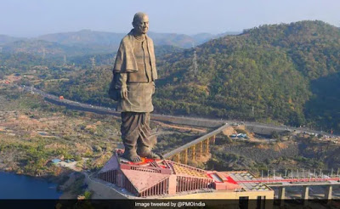](https://2.bp.blogspot.com/-54HouIBIAeQ/W9xz3GQsDkI/AAAAAAAAAec/JT0K6MZMPKsY41pvq7MO-ndfR92JHLD_QCLcBGAs/s1600/Sardar%2BVallabhbhai%2BPatel%2Bstatue.jpg)

**Sardar Vallabhbhai Patel** considered as the **founding father of India**. The project of the statue was announced on **October 7, 2010**. [SVPRET](http://www.statueofunity.in/organization) known as The **Sardar vallabhbhai Patel Rashtriya Ekta Trust** was established for construction of the statue. The Statue of Unity organized a petition which is known as Suraaj (In Hindi "Good Governance") is the worlds largest petition signed by **20 million** people. Also, a marathon was held on 15 December 2013 entitled as "[Run for unity](http://statueofunity.in/campaign/run-for-unity)" in India.

**location**

The statue is situated in the [Narmada District](https://en.wikipedia.org/wiki/Narmada_district) of Gujarat. Facing Narmada Dam near Rajpipla. It is on a river island called Sadhu Bet, **100 km southeast** of [Vadodara city](https://en.wikipedia.org/wiki/Vadodara).

**Architecture**

The statue is designed by [Ram V. Sutar](https://en.wikipedia.org/wiki/Ram_V._Sutar). For design, construction and maintenance [Larsen & Toubro](http://www.larsentoubro.com/) received **420 million** US Dollar. Statues total height from the base is 240m. It is constructed with bronze cladding, cement concrete, and steel framing. Most of the expenses raised by Gujarat Government. But Government of India has also allotted some of the money for it.

[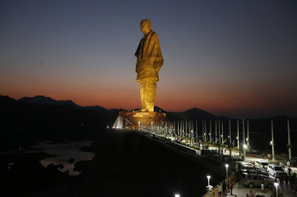](https://1.bp.blogspot.com/-7ByAhk1evMM/W9x0PjY4ZHI/AAAAAAAAAeo/qcNJtXtbgPoQC6JV1nlQ9s1SbIm7t52_gCLcBGAs/s1600/The%2BStatue%2Bof%2BUnity.jpg)

**Height**

182 metres (597ft). 240 metres including base (790ft).

**Beginning date:**

31 October 2013.

[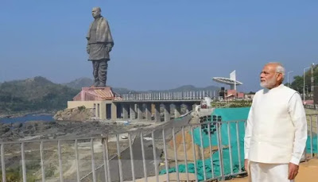](https://3.bp.blogspot.com/-0adG8uWpfCY/W9x2G9CbkXI/AAAAAAAAAfk/UYZdIZWmHjk9gyWVhehTR6qtw6XMB6AbACEwYBhgL/s1600/prime%2Bminister%2BNarendra%2BModi%2Bwith%2Bstatue%2Bof%2Bunity.jpeg)

**Inauguration:**

31 October 2018 by the prime minister [Narendra Modi](https://en.wikipedia.org/wiki/Narendra_Modi) on 143rd birthday of Sardar Vallabhbhai Patel.

**Sardar Vallabhbhai Patel information**

[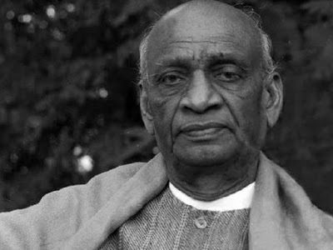](https://1.bp.blogspot.com/-kCezRcyGKM8/W9x0cP-H9hI/AAAAAAAAAew/tiUnJSXaL4YZTO4X72DSjW5Ufk1qUwa9wCLcBGAs/s1600/Sardar%2BVallabhbhai%2BPatel.jpg)

Sardar Vallabhbhai Patel was born in Gujarat on **31 October 1875**. From childhood, he wanted to be a barrister. He wanted to go to England to study. He was so hardworking. He stayed far away from his family only for study. Once Patel had a chance to go to England. But he didn't go. Patel had an elder brother. Patel thought it would be an uncomfortable situation if younger brother goes abroad for study instead of elder brother. So Patel gave the chance to his elder brother. But later he went to England and completed his study in **30 months instead of 36 months**.

He even borrowed books from other lawyers and passed his examination within two years. Vallabhbhai Patel sat up his household in Godhra. Married a woman named. There were two children of them.

Patel's wife had cancer. She was admitted to hospital for so many days. One day later was in court with a case. He was cross-examining a witness. During this situation, a note came into his hands. The note was about his wife's death. But Patel put the note in his pocket and continued the case. Patel was so determined about his work.

[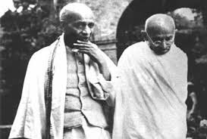](https://1.bp.blogspot.com/-1A1lqAL_26A/W9x0tOcecwI/AAAAAAAAAe8/IykaQn_dV6wvoDQXIxMMGo_yMEx6ftUzACLcBGAs/s1600/Sardar%2BVallabhbhai%2BPatel%2Bwith%2BMahatma%2BGandhi.jpg)

Sardar Vallabhbhai Patel was favorite of [Mahatma Gandhi](https://en.wikipedia.org/wiki/Mahatma_Gandhi). Patel was never wanted to mix up with politics. But after meeting up with [Mahatma Gandhi](https://en.wikipedia.org/wiki/Mahatma_Gandhi) his point of view changed. They stood side by side in so many movements. Quit India movement was one of them. Sardar Vallabhbhai Patel was the first deputy prime minister of India.

[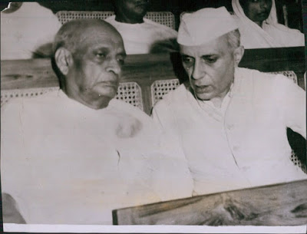](https://2.bp.blogspot.com/-WKWOrJLh7Ow/W9x1FnxmX-I/AAAAAAAAAfE/LsOarwYdeNcz6qggi_7QDLVcUtNx2jInwCLcBGAs/s1600/Sardar%2BVallabhbhai%2BPatel%2Bwith%2BJawaharlal%2BNehru.JPG)

There was a little bit collision between [Jawaharlal Nehru](https://en.wikipedia.org/wiki/Jawaharlal_Nehru) and Patel. But after the death of Mahatma Gandhi that was not seen that much. Before the death of Mahatma Gandhi, Patel was there. He talked with Gandhi about so many things. Mahatma Gandhi told him that Patel and Nehru were partners in so many movements so they shouldn't quarrel with each other.

In 1950 Patel's health was in a bad situation. He was coughing blood. [Maniben Patel](https://en.wikipedia.org/wiki/Maniben_Patel), Patel's daughter took great care of his father but Patel's health was not out of danger. For that Patel went to Bombay and lived in his Birla house. On that house, he breathed his last on 15 December 1950.

**Other, worlds tallest statue's**

**2nd tallest:**

[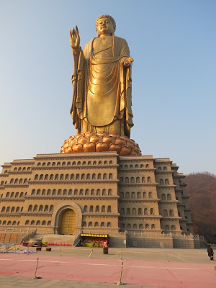](https://3.bp.blogspot.com/-myTwH9vf0f8/W9x1qkNlJJI/AAAAAAAAAfY/Qlo1T51hr2UiKO1gRxC4NH5iBMi0yNatQCLcBGAs/s1600/Spring%2BTemple%2BBuddha.jpg)

[**Spring Temple Buddha**](https://en.wikipedia.org/wiki/Spring_Temple_Buddha) is the worlds second tallest statue. It was 1st until October 2018. The inauguration of the **Sardar Vallabhbhai Patel statue** was in October 2018.

**Details:**

It is a statue of [Vairocana Buddha](https://en.wikipedia.org/wiki/Vairocana). The statue is situated in **Lushan County, Henan, China**.

**Height:**

128metres (420ft). 208 meters including the base (682ft)

**Inauguration date:**

1st September 2008

**3rd tallest:**

[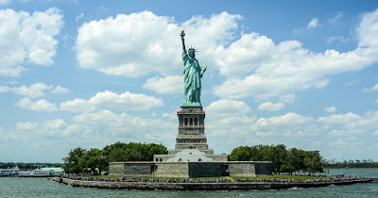](https://4.bp.blogspot.com/-rsw7rHwvINY/W9x1cQouEnI/AAAAAAAAAfQ/sPRSHifT9CcGTyWzEwPLIf28GIBKuz5GACLcBGAs/s1600/Statue%2Bof%2BLiberty.jpg)

[**Statue of Liberty**](https://en.wikipedia.org/wiki/Statue_of_Liberty) is the worlds 3rd tallest statue. It is a gift from France to the people of USA.

**Details**

The statue was designed by [Frederic Auguste Bartholdi](https://en.wikipedia.org/wiki/Fr%C3%A9d%C3%A9ric_Auguste_Bartholdi) and built by [Gustave Eiffel](https://en.wikipedia.org/wiki/Gustave_Eiffel). It is situated on [Liberty island](https://en.wikipedia.org/wiki/Liberty_Island) of New York. It is representing [Libertas](https://en.wikipedia.org/wiki/Libertas), a Roman liberty goddess.

**Height:**

46 meters (151ft 1inch) from copper statue to torch.

93 meters (305ft 1inch) from the ground to the torch.

**Inauguration date:**

October 28, 1886

**Conclusion:**

Sardar Vallabhbhai Patel statue or known as Statue of Unity is now the world's tallest statue. Above I discussed everything about it including 2nd and 3rd tallest statue. Also, there was Sardar Vallabhbhai Patel information. Hope that this will help you a lot. For more query, you can look into our website. Thank you...